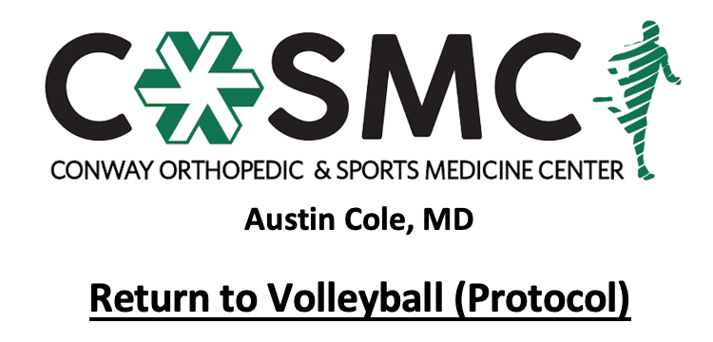

This hitting program is designed as a progressive increase in hitting endurance, power, and strength after a physical aliment that required rest to help in the healing process.

The athlete may continue to progress to the next step of the hitting program when they complete the current hitting day without any pain. Make sure that you report any pain during any phase of the program. Aching in the muscles is okay but if the athlete experiences any pain while hitting, they need to quit for that day. If the pain does not go away after 24 to 48 hours, the athlete should take two days off and then return to the previous days hitting progression. If pain continues to occur, contact your physician.

Sessions of Hitting Program

Hitting should be done Monday, Wednesday and Friday. There needs to be a day of rest in between sessions.

Proper warm-up is important prior to any hitting sessions and should include:
- Jogging
- Shoulder/Scapular exercises
- Stretching
- Pepper with partner or against wall

Take a 3 to 5 minute break in-between sets

After the hitting is completed, cool down should consist of light stretching and jogging. Ice is optional.

WEEK 1

Monday
- 15 tips on box from bow and arrow position- in front of 10ft line
- 15 rolls on box from bow and arrow position-in front of 10ft line

Wednesday
- 10 tips/rolls on box from bow and arrow position- in front of 10ft line
- 20 tips/rolls on box from bow and arrow position-deep
- 10 full swing on box from bow and arrow position-50%

Friday
- 20 tips/rolls on box from bow and arrow position- short and deep
- 15 full swing on box from bow and arrow position-50%
- 10 float serves at 10ft line

WEEK 2

Monday
- 10 tips/rolls with full approach and arm swing
- 20 full swing on box from bow and arrow position-50%
- 10 float serves at 20ft

Wednesday
- 10 full swing on box from bow and arrow position-50%
- 20 full arm swing on box- 50%
- 10 float serves full court

Friday
- 10 full arm swing on box- 50%
- 20 full approach and arm swing- 50%
- 15 float serves full court

WEEK 3

Monday
- 10 full approach and arm swing-50%
- 10 full approach and arm swing-75%
- 10 float serves full court
- 10 top spin serves full court-50% to 75%

Wednesday
- 15 full approach and arm swing-50%
- 15 full approach and arm swing-75%
- 15 serves full court

Friday
- 30 full approach and arm swing-75%
- 15 serves full court
WEEK 4

Monday
- 10 full swing- 50%
- 20 full swing- 75% to 85%

Wednesday
- 10 full swing- 50%
- 10 full swing- 75%
- 10 full swing-100%

Friday
- 30 full swing- 100%

