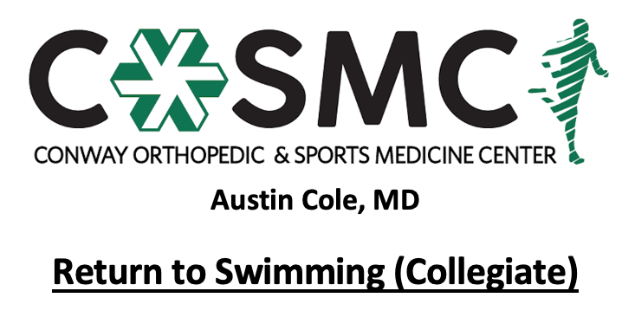

Criteria to initiate program:
- Proper alignment and eccentric control with bilateral and unilateral closed chain movements.
- Perform Upper Extremity Functional Test at >70% to initiate Phase I.
- MMT 5/5 and pain free in all directions.

Key notes:
- Perform program on every other day basis to allow for 24-48 hours of recovery time.
- Perform each level for prescribed number of sessions before moving on to next level- move to next level once able to complete with proper mechanics, good strength, and without symptoms.
- Athletes will progress at different rates through the program dependent upon confidence, degree of inflammation, severity of injury, age, and type of surgical intervention. Pain and swelling are the best guides to determining tolerance at each phase and whether an athlete should progress to the next step.
- Setbacks are common during return to sport progressions and sound judgment should be used regarding an extra rest day(s) or regressing back to prior phase if pain and swelling are problematic.
- Continue with upper extremity, lower extremity and core strengthening exercises 2-3 times a week while progressing program- strengthening exercises may overlap days of swimming program and be performed after; however, must have one complete rest day per week.
- Perform stretching exercises on daily basis.
- Active warm-up to initiate each session with cooldown following. Ice for 10-15 minutes following session as pain and swelling dictate.

Phase I: Stroke technique
Perform each level 3 times without symptoms prior to moving to next level. If symptoms occur, return to previous level. Focus on stroke technique and restoring normal mechanics.
- Level 1:
  - Warm up: 300-400 yards
  - Drills focusing on stroke technique: 300-500 yards total with 20-30 second rest between repetitions
  - Kick: 400-600 yards on side or back in streamlined position (if pain free) or arms at side. No kickboard. With fins or zoomers.
  - No intervals.
  - No pull set.
  - Cool down: 200-300 yards

- Level 2:
  - Warm up: 600-700 yards
  - Drills focusing on stroke technique: 400-600 yards total with 10-20 second rest between repetitions
  - Kick: 500-900 yards on side or back in streamlined position (if pain free) or arms at side. No kickboard. With fins or zoomers.
  - No intervals.
  - No pull set.
  - Cool down: 300-400 yards
- Level 3:
  - Warm up: 700-900 yards
  - Drills focusing on stroke technique: 600-700 yards total with 10-15 second rest between repetitions
  - Kick: 700-900 yards on side or back in streamlined position (if pain free) or arms at side. No kickboard. With fins or zoomers.
  - Intervals:
    - 1 set at 70% effort with 5-10 second rest between repetitions
    - 1 set at 10 seconds slower than regular practice pace with 5-10 second rest between repetitions
    - Total yardage for intervals: 200-500
  - No pull set.
  - Cool down: 400-500 yards

Phase II: Build muscular and cardiovascular fitness
Return to organized practices with swimmer’s team. Perform each level for 1 week without symptoms prior to progressing to next level. If symptoms occur, return to previous level. Continue to swim with day off in between and 1 full day of rest per week.

- Level 1:
  - Warm up: 900-1100 yards
  - Team drills (perform at beginning and end of practice): 700-900 yards with 10-15 second rest between repetitions
  - Kick: 700-900 yards on side or back with board or in streamlined position (if pain free), or arms at side. With fins or zoomers.
  - Intervals:
    - Gradually increase number of sets while maintaining correct stroke technique
    - 5-10 second rest between repetitions
    - Total yardage for intervals: 500-1000
  - No pull set.
  - Cool down: 500-600 yards
- Level 2:
  - Warm up: 1000-1200 yards
  - Drill set incorporated at end of workout: 800-1000 yards with 5-15 second rest between repetitions
  - Kick: 700-900 yards on side or back with board or in streamlined position (if pain free), or arms at side. Fins and zoomers optional.
  - Intervals:
    - Start at 5-10 seconds slower than pre-injury pace and gradually progress to pre-injury pace
    - 3-10 second rest between repetitions
    - Total yardage for intervals: 800-1300

  - Pull set:
    - Start conservatively, 200-300 yards
    - Increase pulling yardage by 300 as tolerated
    - No paddles.
    - Stop immediately if pain or discomfort felt.
  - Cool down: 500-600 yards

Phase III: Doubles Practices
Return to performing two practices in a single day if applicable. Full participation in first practice. Second practice must progress through entire Phase II regarding distance and speed progressions. Slow integration of pull buoys or paddles. Pull buoys, paddles, kickboard, and fins are held until Phase III to allow swimmer to maximize technique without increased extremity loading of affected extremity.

