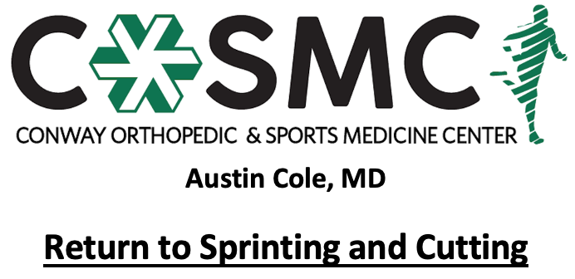

Criteria to initiate program:
- Proper alignment and eccentric control with bilateral and unilateral closed chain movements.
- Complete 4 week return to jogging program to build aerobic base to prepare for more intense runs. Athlete should be able to jog for 10 consecutive minutes prior to starting program. Goal is not speed or distance when jogging 10 minutes but having a solid aerobic foundation to build upon.
- Single leg single hop test and single leg press >70% on Limb Symmetry Index.

Key notes:
- Perform program on every other day basis to allow for 24-48 hours recovery time.
- Perform each level 2-3 sessions before moving on to the next level- move to the next level once able to complete with proper mechanics, good strength, and without symptoms.
- Adjust volume and work: rest ratio per sport/position.
- Athletes will progress at different rates through the program dependent upon degree of inflammation, severity of injury, age, and type of surgical intervention. Pain and swelling are the best guides to determining tolerance at each phase and whether an athlete should progress to the next step. Progression through the phases is combined evaluation and guidance of rehab provider and coach.
- Setbacks are common during return to sport progressions and sound judgment should be used regarding an extra rest day(s) or regressing back to prior phase if pain and swelling are problematic.
- Continue with strengthening exercises 2-3 times a week while progressing running program- strengthening exercises may overlap days of running program and be performed after running program; however, must have one complete rest day per week.
- Active warm-up to initiate each session with cooldown following. Ice for 10-15 minutes following session as pain and swelling dictate.

Active warm-up
Pre-running drills (15 yards down and back each): jogging, skipping, side shuffle, backpedal, high knees, butt kicks, grapevine
Dynamic stretching (10 yards down and back each): single leg RDL, quad stretch, side lunge, forward lunge, reverse lunge, knee tucks, glute stretch, inchworms
Footwork drills: speed ladder or hurdles

Cool down
5-10 minutes global lower extremity and trunk stretching
Ice for 10-15 minutes as pain and swelling dictates

Phase I:
- Goal: build confidence with running with low impact, linear running drills with minimal acceleration and deceleration
- Limb Symmetry Index: >70% with single leg single hop and single leg press
- Linear running: start at 50% intensity and progress to 75% intensity, gradually work on decreasing distance for acceleration and deceleration
- Initiate light change of direction with S-run (no sharp cutting or planting)
- Exercises: linear running, backpedal, sprint transitions (forward/backwards and backwards/forwards), “S-runs”
- Work: rest ratio specific to sport demands

Phase II:
- Goal: speed development and running technique, initiate change in direction with visual stimulus of place to change direction progressing to auditory stimulus
- Limb Symmetry Index: >80% with single leg single hop and single leg press, full prone knee flexion ROM (test with Prone Knee Bend) to normalize running mechanics
- Linear running: progress from 75% intensity to 90% intensity
- Multidirectional running/cutting: progress from 50% intensity to 75% intensity
- Exercises: linear running, backpedal, sprint transitions (forward/backwards and backwards/forwards), cone drills/cutting, backpedal into sprint in different directions (lateral, forward, forward angle), backpedal turn and run, run and jump stop
- Work: rest ratio resembles sport demands

Phase III:
- Goal: build repeated sprint ability, introduce sport-specific demands with participation in non-contact team drills, change in direction with reactive or auditory stimulus
- Linear running: 90-100% intensity
- Multidirectional running/cutting: 75% intensity progressing to 100% intensity
- Exercises: linear running, backpedal, sprint transitions (forward/backwards and backwards/forwards), cone drills/cutting, backpedal into sprint in different directions (lateral, forward, forward angle), backpedal turn and run, run and jump stop
- Work: rest ratio resembles sport demands

Phase IV:
- Goal: maximal speed including changes in direction, acceleration, and deceleration, technical skills progression and participation in team drills with limited contact
- Limb Symmetry Index: >90% on single leg single hop and single leg press
- Linear and multidirectional running: 100% intensity
- Work: rest ratio resembles sport demand

Phase V:
- Goal: full contact in training sessions with all scenarios (change in direction, speed, jumping, tackling, etc) to prepare for game play
- Full participation in team conditioning
- Linear and multidirectional running: 100% intensity
- Work: rest ratio resembles sport demands
:

