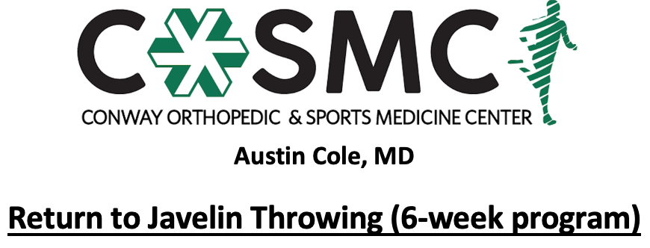

Criteria to initiate program:
- Proper alignment and eccentric control with bilateral and unilateral closed chain movements.
- Perform Upper Extremity Functional Test at >70% to initiate Phase I.
- MMT 5/5 and pain free in all directions.

Key notes:
- Perform program on every other day basis to allow for 24-48 hours of recovery time. Max of throwing 3 times a week while progressing through program.
- Perform each level painfree before moving to next level- move to next level once able to complete with proper mechanics, good arm strength, and without symptoms.
- Athletes will progress at different rates through the program dependent upon confidence, degree of inflammation, severity of injury, age, and type of surgical intervention. Pain and swelling are the best guides to determining tolerance at each phase and whether an athlete should progress to the next step. Progression through the phases is combined evaluation and guidance of rehab provider and coach.
- Setbacks are common during return to sport progressions and sound judgment should be used regarding an extra rest day(s) or regressing back to prior phase if pain and swelling are problematic.
- Athletes should report any pain during program. If athlete experiences pain while throwing, then the program is to be stopped for the day. During next throwing day, the athlete should return to the last level they threw without pain. If pain occurs again, contact the physician or rehab provider.
- Continue with strengthening exercises 2-3 times a week while progressing throwing program- strengthening exercises may overlap days of program and be performed after throwing program; however, must have one complete rest day per week.
- Continue with stretching exercises on daily basis.
- Active warm-up to initiate each session with cooldown following. Ice for 10-15 minutes following session as pain and swelling dictate.
- Brace on through all phases if prescribed by physician.

Active warm-up
Pre-running drills (15 yards down and back each): jogging, skipping, side shuffle, backpedal, high knees, butt kicks, grapevine
Dynamic stretching routine to upper extremity, trunk, and lower extremity (10 yards down and back each): single leg RDL, quad stretch, side lunge, forward lunge, reverse lunge, knee tucks, glute stretch, inchworms
Footwork drills
Throwing warm up: start at 30 feet and gradually move back to scheduled distance as arm loosens up. Start counting prescribed number of throws once at scheduled distance.

Cool down
5-10 minutes global upper extremity, core, and lower extremity stretching
Ice for 10-15 minutes as pain and swelling dictates

Phase I:
Implement: 400g Turbo Javelin or 400g Javelin Ball
Throwing Stance: Typical javelin stance with left (or right) hip facing target, throwing arm up and externally rotated (palm up), non-throwing arm out in front in internal rotation (palm down), ~80% of your weight on the back leg, slight bend in back leg
Throwing Motion: Shift weight forward on to plant leg, rotate hips and shoulders forward, throwing arm rotates up and over the top, again only with slight bend in the elbow, non-throwing arm is flexed into the side, finish high on tops of your block leg with shoulders and hips square and facing target. Incorporate these mechanics for the remainder of the program. Progress to a walking 3-step by the 3rd session.

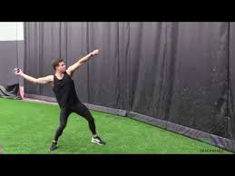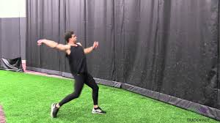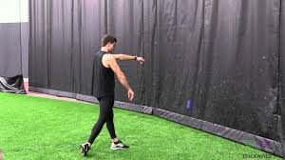

WEEK 1
Monday | Wednesday | Friday
Warm-up | Warm-up | Warm-up
45 feet: 15 throws | 45 feet: 20 throws | 60 feet: 15 throws
Rest: 10 minutes | Rest: 10 minutes | Rest: 10 minutes
Warm-up | Warm-up | Warm-up
45 feet: 15 throws | 45 feet: 15 throws | 60 feet: 15 throws
 | Rest: 10 minutes | *Walking 3-step
 | Warm-up
 | 45 feet: 15 throws
WEEK 2
Monday | Wednesday | Friday
Warm-up | Warm-up | Warm-up
60 feet: 20 throws | 90 feet: 15 throws | 90 feet: 20 throws
Rest: 10 minutes | Rest: 10 minutes | Rest: 10 minutes
Warm-up | Warm-up | Warm-up
60 feet: 15 throws | 90 feet: 15 throws | 90 feet: 15 throws
Rest: 10 minutes | *Jogging 3-step | Rest: 10 minutes
Warm-up |  | Warm-up
60 feet: 15 throws  *Walking 3-step |  | 90 feet: 15 throws  *Jogging 3-step
Phase II:
Complete progressions from standing to 3-step to 5-step to full approaches each session as you would in a typical practice. Pay close attention to the prescribed implement weight and effort level for each session.

Implement: 600g Women’s Javelin or 600g Javelin Ball
20 standing
10 3-step
5 5-step
WEEK 3
Monday | Wednesday | Friday
50% Effort | 50% Effort | 75% Effort
WEEK 4
Monday | Wednesday | Friday
75% Effort | 100% Effort | 100% Effort
Implement: 800g Men’s Javelin or 800g Javelin Ball
20 Standing
10 3-step
5 5-step
3-5 Full
WEEK 5
Monday | Wednesday | Friday
50% Effort | 50% Effort | 75% Effort
WEEK 6
Monday | Wednesday | Friday
75% Effort | 100% Effort | 100% Effort

Phase III: Meet Simulation
- Full warm up
- Full throw progression: standing throws, 3-step throws, 5-step throws, full approach run throughs
- 2-3 full “practice throws” 80-90% effort
- Prelims Simulation: 100% effort
  - 3 full throws with 10 minutes between each throw. Stay loose between throws.
- 15 minute rest break.
- Finals Simulation: 100% effort
  - Run throughs, practice throws as needed
  - 3 full throws with 10 minutes between each throw. Stay loose between throws.

