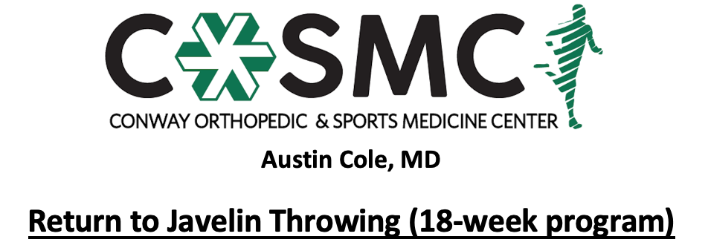

Criteria to initiate program:
- Proper alignment and eccentric control with bilateral and unilateral closed chain movements.
- Perform Upper Extremity Functional Test at >70% to initiate Phase I.
- MMT 5/5 and pain free in all directions.

Key notes:
- Perform program on every other day basis to allow for 24-48 hours of recovery time. Max of throwing 3 times a week while progressing through program.
- Perform each level pain free before moving to next level- move to next level once able to complete with proper mechanics, good arm strength, and without symptoms.
- Athletes will progress at different rates through the program dependent upon confidence, degree of inflammation, severity of injury, age, and type of surgical intervention. Pain and swelling are the best guides to determining tolerance at each phase and whether an athlete should progress to the next step. Progression through the phases is combined evaluation and guidance of rehab provider and coach.
- Setbacks are common during return to sport progressions and sound judgment should be used regarding an extra rest day(s) or regressing back to prior phase if pain and swelling are problematic.
- Athletes should report any pain during program. If athlete experiences pain while throwing, then the program is to be stopped for the day. During next throwing day, the athlete should return to the last level they threw without pain. If pain occurs again, contact the physician or rehab provider.
- Continue with strengthening exercises 2-3 times a week while progressing throwing program- strengthening exercises may overlap days of program and be performed after throwing program; however, must have one complete rest day per week.
- Continue with stretching exercises on daily basis.
- Active warm-up to initiate each session with cooldown following. Ice for 10-15 minutes following session as pain and swelling dictate.
- Brace on through all phases if prescribed by physician.

Active warm-up
Pre-running drills (15 yards down and back each): jogging, skipping, side shuffle, backpedal, high knees, butt kicks, grapevine
Dynamic stretching routine to upper extremity, trunk, and lower extremity (10 yards down and back each): single leg RDL, quad stretch, side lunge, forward lunge, reverse lunge, knee tucks, glute stretch, inchworms
Footwork drills
Throwing warm up: start at 30 feet and gradually move back to scheduled distance as arm loosens up. Start counting prescribed number of throws once at scheduled distance.

Cool down
5-10 minutes global upper extremity, core, and lower extremity stretching
Ice for 10-15 minutes as pain and swelling dictates

Phase I:
Implement: Baseball
Throwing stance: Stand with body facing your target. Both feet facing target, hips slightly open and rotated towards throwing side, throwing arm straight back in external rotation (turned upward), non-throwing arm straight out in front in internal rotation (thumb down).
Throwing motion: Rotate throwing arm up and over the top, simultaneously flexing the non-throwing arm into your side. Elbow of throwing arm should have minimal bend.
*Gradually incorporate a forward step into the throw by week 2.
*Rest 3-5 mins between each set of throws

WEEK 1
Monday | Wednesday | Friday
45 feet: 2 sets of 20 throws | 45 feet: 2 sets of 20 throws | 60 feet: 2 sets of 20 throws
Implement: Baseball
Throwing Stance: Typical javelin stance with left (or right) hip facing target, throwing arm up and externally rotated (palm up), non-throwing arm out in front in internal rotation (palm down), ~80% of your weight on the back leg, slight bend in back leg
Throwing Motion: Shift weight forward on to plant leg, rotate hips and shoulders forward, throwing arm rotates up and over the top, again only with slight bend in the elbow, non-throwing arm is flexed into the side, finish high on tops of your block leg with shoulders and hips square and facing target. Incorporate these mechanics for the remainder of the program.

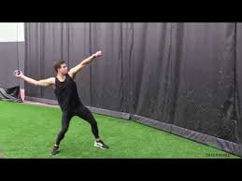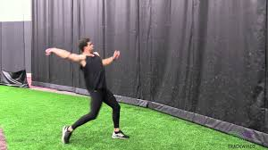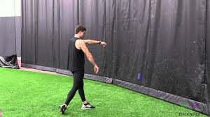

WEEK 2
Monday | Wednesday | Friday
60 feet: 2 sets of 20 throws | 75 feet: 2 sets of 20 throws | 75 feet: 2 sets of 20 throws
Implement: Baseball
Throwing Motion: Progress to a walking 3 step. Increase speed each week.
WEEK 3
Monday | Wednesday | Friday
2 sets of: 15 throws at 75 feet + 10 throws at 90 feet | 2 sets of: 15 throws at 75 feet + 10 throws at 90 feet | 90 feet: 2 sets of 20 throws
Implement: Baseball, then Softball or 200g Javelin Ball

WEEK 4: progress to jogging 3-step
Monday | Wednesday | Friday
2 sets of: 15 throws at 90 feet with baseball + 10 throws at 75 feet with softball or jav ball | 2 sets of: 15 throws at 90 feet with baseball + 10 throws at 75 feet with softball or jav ball | 2 sets of: 15 throws at 90 feet with baseball + 10 throws at 75 feet with softball or jav ball
WEEK 5: progress to jogging 5-step
Monday | Wednesday | Friday
2 sets of: 15 throws at 90 feet + *10 throws at 105 feet (5 step) | 2 sets of: 15 throws at 90 feet + *10 throws at 105 feet (5 step) | 2 sets of: 15 throws at 90 feet + *10 throws at 105 feet (5 step)

Phase III: Speed Progression
Implement: 400g Turbo Javelin or 400g Javelin Ball
Throwing Motion: Progress to a full speed 3 step by week 6 and full speed 5 step by week 8

WEEK 6
Monday | Wednesday | Friday
90 feet: 2 sets of 20 throws (3 step) | 90 feet: 2 sets of 20 throws (3 step) | 90 feet: 2 sets of 20 throws (3 step)

WEEK 7: progress to full speed 3-step
Monday | Wednesday | Friday
2 sets of: 15 throws at 90 feet (3 step) + 10 throws at 105 feet (5 step) | 2 sets of: 15 throws at 90 feet (3 step) + 10 throws at 105 feet (5 step) | 2 sets of: 15 throws at 90 feet (3 step) + 10 throws at 105 feet (5 step)

WEEK 8
Monday | Wednesday | Friday
105 feet: 2 sets of 20 throws (5 step) | 105 feet: 2 sets of 20 throws (5 step) | 105 feet: 2 sets of 20 throws (5 step)

WEEK 9
Monday | Wednesday | Friday
2 sets of: 15 throws at 105 feet (5 step) + 10 throws at 120 feet (5 step) | 2 sets of: 15 throws at 105 feet (5 step) + 10 throws at 120 feet (5 step) | 2 sets of: 15 throws at 105 feet (5 step) + 10 throws at 120 feet (5 step)

Phase IV: Weighted Progression
Implement: Javelin or javelin ball
Throwing motion: Complete progressions from standing to 3-step to 5-step to full approaches each season as you would in a typical practice. Pay close attention to the prescribed implement weight and effort level for each session.

Implement: 400g turbo jav or 400g javelin ball
Perform 10 standing, 5 3-step, 5 5-step, 5 full

WEEK 10
Monday | Wednesday | Friday
70% effort | 50% effort | 70% effort

WEEK 11
Monday | Wednesday | Friday
80% effort | 60% effort | 80% effort

Implement: 400g turbo jav or 400g javelin ball
Perform 5 standing, 3 3-step, 3 5-step, and 3 full
600g women’s javelin or 600g javelin ball
Perform 5 standing, 2 3-step, 2 5-step, 2 full

WEEK 12
Monday | Wednesday | Friday
90% with 400g  70% with 600g | 70% with 400g  50% with 600g | 90% with 400g  70% with 600g

Implement: 600g women’s javelin or 600g javelin ball
Perform 10 standing, 5 3-step, 5 5-step, and 5 full

WEEK 13
Monday | Wednesday | Friday
70% effort | 50% effort | 70% effort

WEEK 14
Monday | Wednesday | Friday
80% effort | 60% effort | 80% effort

Implement: 600g women’s javelin or 600g javelin ball
Perform 5 standing, 3 3-step, 3 5-step, and 3 full
800g men’s javelin or 800g javelin ball
Perform 5 standing, 2 3-step, 2 5-step, and 2 full

WEEK 15
Monday | Wednesday | Friday
90% with 600g  70% with 800g | 70% with 600g  50% with 800g | 90% with 600g  70% with 800g

Implement: 800g men’s javelin or 800g javelin ball
Perform 10 standing, 5 3-step, 5 5-step, and 5 full

WEEK 16
Monday | Wednesday | Friday
70% effort | 50% effort | 70% effort

WEEK 17
Monday | Wednesday | Friday
80% effort | 60% effort | 80% effort
WEEK 18
Monday | Wednesday | Friday
90% effort | 70% effort | 90% effort

Phase V: Meet Simulation
- Full warm up
- Full throw progression: standing throws, 3-step throws, 5-step throws, full approach run throughs
- 2-3 full “practice throws” 80-90% effort
- Prelims Simulation: 100% effort
  - 3 full throws with 10 minutes between each throw. Stay loose between throws.
- 15 minute rest break
- Finals Simulation: 100% effort
  - Run throughs, practice throws as needed
  - 3 full throws with 10 minutes between each throw. Stay loose between throws.

