

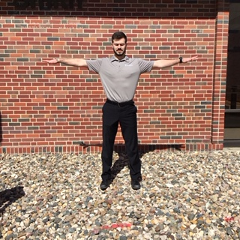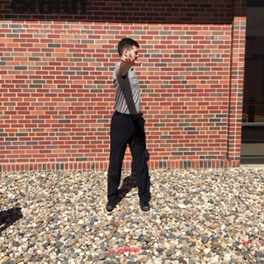
1a: Windmills (standing tall) x25
1a: Standing tall, feet shoulder width and arms out to your sides, begin to rotate your arms and trunk back and forth like a merry-go-round. Keep your arms elevated throughout the exercise.

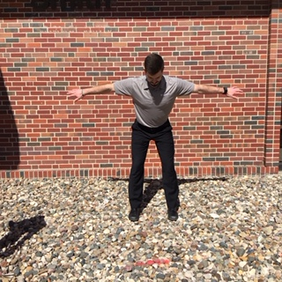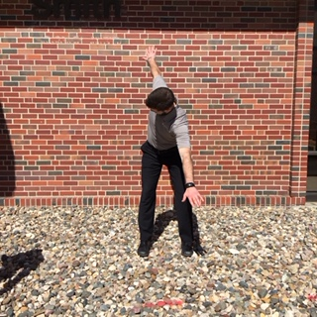
1b: Windmills (in golf posture) x25
1b: Take your 6-iron posture, repeat the arm movements while keeping a stable pelvis posture.

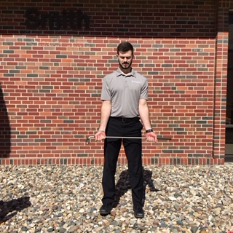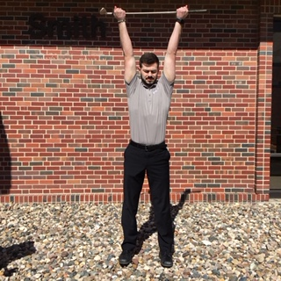
2: Palm-up club lifts x25
2: Start by grabbing an iron. Hold it shoulder width apart, palms up. Slowly raise the club as high as possible while pushing the club away from your body.

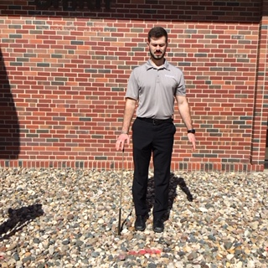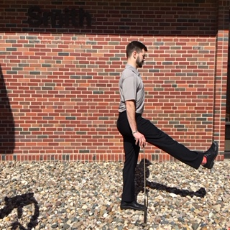
3: Leg swings x25 each side
3: Stand on one leg with club in opposite arm for support. Swing one leg forward/ back. Then switch the club to other hand, and repeat with other leg.

4: All-4s reach-backs x25 each side
4: Get into “all-4s position” on hands and knees. Place your left hand behind your head. Keep your spine stable and rotate your left elbow up to the sky, then downward toward the opposite elbow. Repeat on each side.

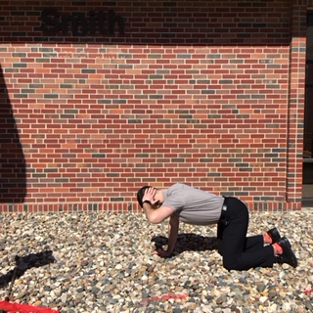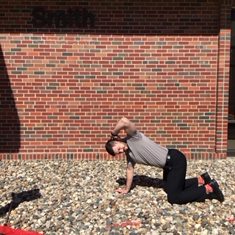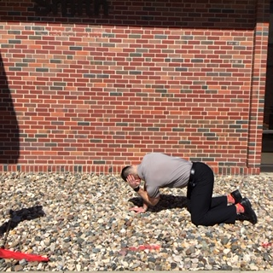
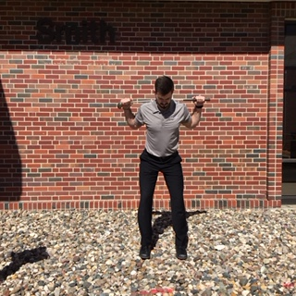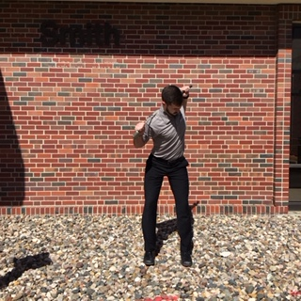
5: W-turns x25 ea ch side
5: Place a club across your shoulders behind your neck. Grab both ends of the club with your hands (your arms should make the shape of a “W”.) Get into your 6-iron posture and make big shoulder turns back and forth. Maintain your posture with each turn.

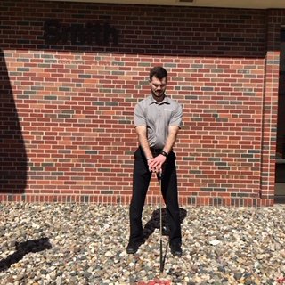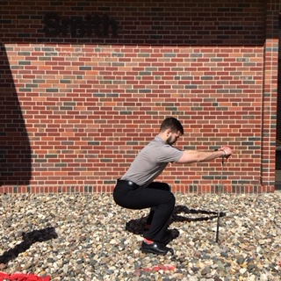
6: Supported squat: x20
6: Hold on to a golf club or golf cart and perform slow squat (as deep as possible without pain), keeping your heels on the ground

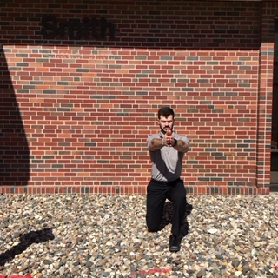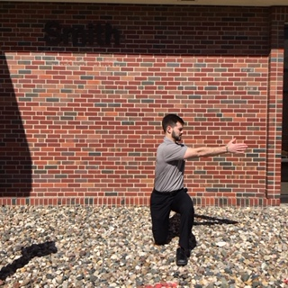
7: Lunge with twist: x10 each side
7: Step into a lunge position with your knee in line over your ankle and your trunk upright. Once in a good lunge, rotate your upper body over your front leg. Make sure to keep your weight centered over your front foot. Then return to standing and repeat with opposite side.

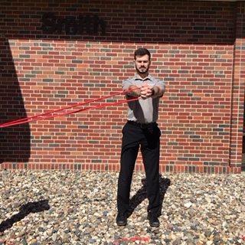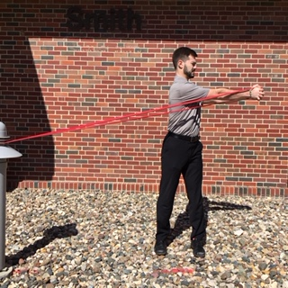
8: Standing trunk rotation with band x20 each way
8: Tie a theraband to a stable object (cart, tree, etc.) Stand tall with feet shoulder width apart and arms straight out in front of you hold the band. Rotate your body away from the band. Turn around and repeat to opposite direction.

9: Lunge with band twist x10 each side
9: Tie your theraband to stable object again. Step into a good lunge position with your outer leg (leg furthest away from band) and rotate your trunk away from band. Return to standing, then repeat all repetitions on this side before turning around and doing other direction.

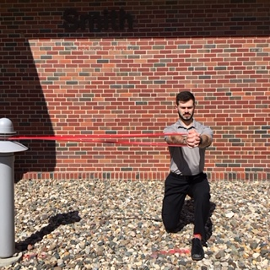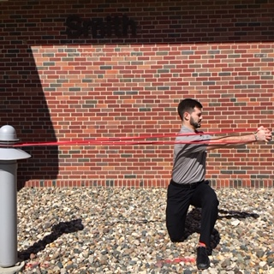
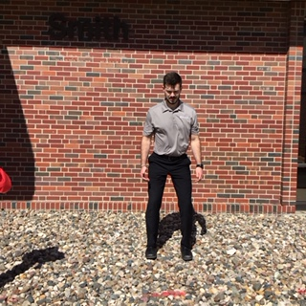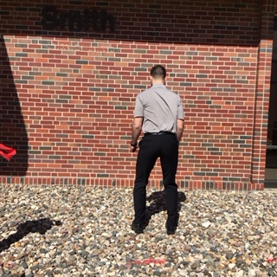
10a: Jump Turns 180-degree x5 each direction
10a: Attempt to jump and spin, focusing on a soft controlled landing. Practice 180-deg jump spins.
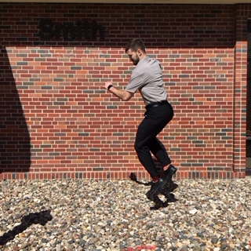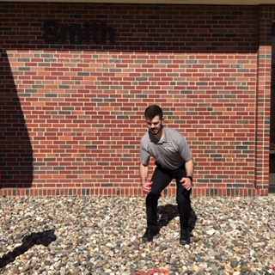
10b: Jump Turns 360-degree x5 each direction
10b: When you can do these easily, progress to 360-deg jump turns. Emphasis should be on slow, controlled landing with each repetition.

