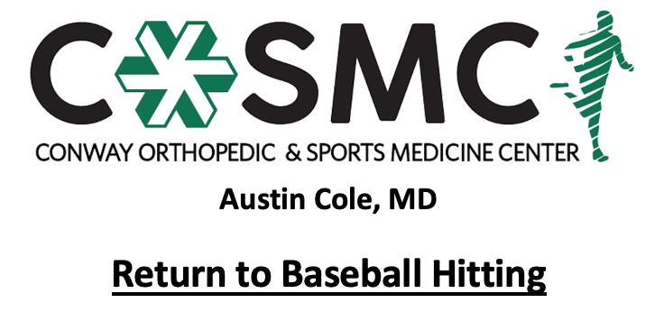

Program is to be performed in conjunction with Return to Baseball or Return to Softball program for returning to play. Athlete is able to initiate Return to Hitting: Phase I 2 weeks after initiating respective program.

Criteria to initiate program:
- Proper alignment and eccentric control with bilateral and unilateral closed chain movements.
- Complete 4 week return to jogging program to build aerobic base to prepare for more intense runs. Athlete should be able to jog for 10 consecutive minutes prior to starting program. Goal is not speed or distance when jogging 10 minutes but having a solid aerobic foundation to build upon.
- Single leg single hop test and single leg press >80% on Limb Symmetry Index.

Key notes:
- Perform program on every other day basis to allow for 24-48 hours of recovery time.
- Perform each level for 2-3 sessions before moving on to next level- move to next level once able to complete with proper mechanics, good strength, and without symptoms.
- Brace on when prescribed by MD.
- Athletes will progress at different rates through the program dependent upon confidence, degree of inflammation, severity of injury, age, and type of surgical intervention. Pain and swelling are the best guides to determining tolerance at each phase and whether an athlete should progress to the next step.
- Setbacks are common during return to sport progressions and sound judgment should be used regarding an extra rest day(s) or regressing back to prior phase if pain and swelling are problematic.
- Continue with lower extremity, core and rotator cuff strengthening exercises 2-3 times a week while progressing program- strengthening exercises may overlap days of hitting program and be performed after hitting; however, must have one complete rest day per week.
- Active warm-up to initiate each session with cooldown following. Ice for 10-15 minutes following session as pain and swelling dictate.
- It is crucial to work with a coach for evaluation and correction of swing for biomechanical faults or inefficiencies.

Active warm-up
Pre-running drills (15 yards down and back each): jogging, skipping, side shuffle, backpedal, high knees, butt kicks, grapevine
Dynamic stretching routine to upper extremity, trunk, and lower extremity (10 yards down and back each): single leg RDL, quad stretch, side lunge, forward lunge, reverse lunge, knee tucks, glute stretch, inchworms, arm swings

Cool down
5-10 minutes global upper extremity, trunk, and lower extremity stretching
Ice for 10-15 minutes as pain and swelling dictates

Phase I: Off a Tee
- Level 1: 50% effort with tee set-up for ball placement at middle of plate and waist height
  - 1 x 25 swings
  - Focus on addressing mechanics of swing
- Level 2: 50% effort with tee set-up at waist height
  - 1 x 15 swings at middle of plate
  - 1 x 15 swings with tee set-up at inside corner of plate
  - 1 x 15 swings with tee set-up at outside corner of plate
- Level 3: 75% effort with tee set-up at waist height
  - 1 x 15 swings at middle of plate
  - 1 x 15 swings with tee set-up at inside corner of plate
  - 1 x 15 swings with tee set-up at outside corner of plate
- Level 4: 75% effort off tee at varying heights
  - 20 swings at middle of plate with 5 at chest height, 10 at waist height, and 5 at just above knees
  - 20 swings at inside corner of plate with 5 at chest height, 10 at waist height, and 5 at just above knees
  - 20 swings at outside corner of plate with 5 at chest height, 10 at waist height, and 5 at just above knees
- Level 5: 90-95% effort off tee at varying heights
  - 20 swings at middle of plate with 5 at chest height, 10 at waist height, and 5 at just above knees
  - 20 swings at inside corner of plate with 5 at chest height, 10 at waist height, and 5 at just above knees
  - 20 swings at outside corner of plate with 5 at chest height, 10 at waist height, and 5 at just above knees

Phase II: Soft Toss (Underhand Toss)
Perform 10-15 swings off tee as warm-up prior to each level in Phase II.
- Level 1: 2 x 25 swings of soft toss at 50% effort with placement at waist and middle of plate
  - Focus on addressing mechanics of swing
- Level 2: 50% effort at varying heights, all placed at middle of plate
  - 10 swings with ball at waist height, 10 swings with ball at chest height, 10 swings with ball at just above knees
- Level 3: 75% effort at varying heights, all placed at middle of plate
  - 10 swings with ball at waist height, 10 swings with ball at chest height, 10 swings at just above knees
- Level 4: 75% effort at varying heights and placement
  - 30 swings at middle of plate (10 at waist height, 10 at chest height, 10 at just above knees)
  - 10 swings with ball placed at outside corner
  - 10 swings with ball placed at inside corner
- Level 5: 90-95% effort at varying heights and placement
  - 30 swings at middle of plate (10 at waist height, 10 at chest height, 10 at just above knees)
  - 15 swings with ball placed at outside corner
  - 15 swings with ball placed at inside corner

Phase III: Simulated Hitting
Perform 10-15 swings of soft-toss as warm-up prior to each level in Phase III.
- Level 1: 50% effort with randomized height of pitch
  - 30 swings of fastballs: 10 inside, 10 outside, 10 middle of plate
- Level 2: 75% effort with randomized placement
  - 25 swings against fastballs
  - 15 swings against change-ups
- Level 3: 75% effort with randomized placement
  - 25 swings against fastballs
  - 15 swings against change-ups
  - Ages 14 and above: 15 swings against curveballs

Phase IV: Pitch Type Challenge
Perform 10-15 swings of soft-toss as warm-up.
- Level 1: 90-100% effort with randomized placement and pitch type
  - 25 swings against fastball
  - 15 swings against change-ups
  - Ages 14 and above: 15 swings against curveballs
Phase V: Full Participation
- Full unrestricted play with playing time limited initially and progressing to unlimited minutes in preparation for game play

