**Ulnar Collateral Ligament Repair and Bridge**

Post-Operative Protocol

**\*AVOID ALL VALGUS STRESS**

**Post-Op – Week 2 (0-14 days)**

Immobilization in splint at 70**°**- MD directed

MD visit 7-14 days: Removal of splint/sutures

● Place in fully opened brace (brace for 5 weeks)

3 times per day: out of brace to work on elbow extension

Light gripping exercises

Wrist ROM

Modalities PRN

**Week 2 – Week 4 (15-28 days)**

Brace at all times except for ROM with therapist or showering

May come out of brace for ROM program

Begin elbow ROM

● A/AA ROM flexion/extension

● NO forced flexion

● Forearm pronation/supination

Begin pain free isometrics

● Wrist

● Elbow

● Shoulder (except IR/ER)

Begin manual scapular stabilization exercises

Evaluate/improve kinetic chain deficits

● Core activation

● Lower extremity flexibility/activation

● Lower body blood flow restriction training (MD approval needed)

Modalities PRN

**Week 4– Week 8 (29-56 days)**

May come out of brace for ROM program

● Discontinue brace at 6 weeks post-op (42 days)

● If full ROM is not achieved at 6 weeks, contact physician’s office

Increase ROM gradually

NO forced flexion

Begin wrist and elbow isotonics (gradual progression)

Advance scapular s stabilization exercises

Advance to progressive shoulder strengthening

● Progressive ER/IR: Walkouts→ER to neutral→Full ER

Continue improving kinetic chain deficits

**Week 8 – Week 10 (57-70 days)**

Progress wrist, elbow and shoulder isotonics

● Progressive eccentric work

● Manual resistance exercises

● Advance rotator cuff strengthening to overhead position

May initiate two-handed plyometrics at 8 weeks

**Week 10 – Week 12 (71-84 days)**

Advance elbow and wrist strengthening (stress eccentrics)

Continue to progress shoulder into advanced strengthening exercises

May initiate one-handed plyometrics at 10 weeks

**Week 12 – Week 16 (85-112 days)**

Continue to emphasize shoulder strength (rotator cuff and scapular stabilizers)

Continue endurance training

May initiate throwing mechanics drills

Continue kinetic chain progression

MD visit for possible initiation of interval throwing program

● **Week 12** – ***Positional*** players may initiate hitting progression

● **Week 14** – ***Positional*** players may initiate interval throwing program

***Pitchers*** may initiate hitting progression

● **Week 16** – ***Pitchers*** may initiate interval throwing program

**Return Phase:**

Recommend MD consult at end of flat ground throwing program

Recommend MD consult at end of mound progression

**Shoulder/Scapula Exercises**

These exercises and stretches were designed to work on the flexibility and strengthening of your shoulder/scapula muscles. They will help ensure that your body is moving properly; decreasing the stress on your shoulders and elbows. You should also stretch your lower body muscles to ensure a proper kinetic chain.

If you are a competitive overhead athlete, these exercises/stretches will continue to be a part of your prehab throughout your athletic career. This program should be initiated **six weeks** before your season starts and continued throughout your season. During the off season, you will continue to perform the exercises; however, you will not need to perform them as often (about 50% as much).

Perform your lower body stretching and your sleeper stretch three times per day. From the program, pick one or two exercises from each of the four pages to perform; making sure to rotate through all of them. These exercises should be performed every other day.

**VIDEO LINK: Shoulder/Scapula Exercise Videos for Overhead Athlete Program on YouTube.**

**https://youtube.com/playlist?list=PLQaGCY5jUuj1-PYdqByD-3JoYSbVSMMOU**

*Perform the following stretches:

**Sleeper stretch Cross body horizontal**

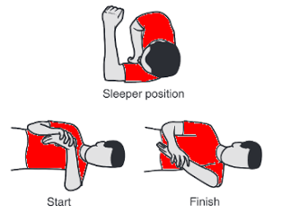 **adduction stretch**

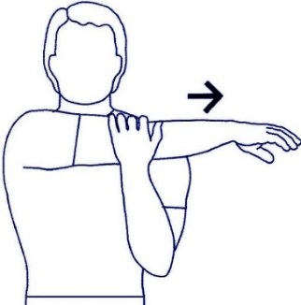

**Sleeper stretch:** Lie on your side on a firm, flat surface with the affected shoulder under you and your arm bent. You can place your head on a pillow for comfort, if needed.

Use your unaffected arm to slowly push your affected arm down towards the hard surface. You should feel a stretch in the back of your affected shoulder.

**Cross body stretch:** Stand with good posture. Cross your arm over your chest and hold. If you do not feel a stretch, hold this position while trying to squeeze your shoulder blades together. You should feel a stretch in the back of your affected shoulder.

Hold both positions for 30 - 45 seconds. Perform 3 - 4 reps of each, 3 - 4 times per day.

